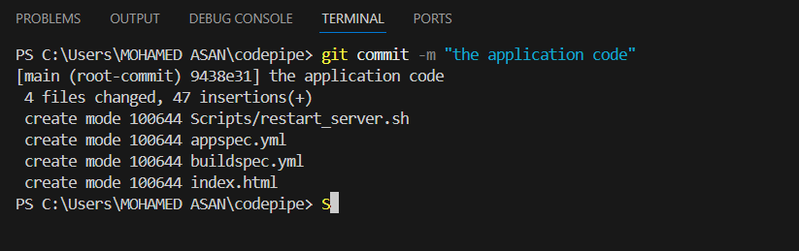

Pushed local to repo :

Code pushed to repo :

Creating branch and pushing file to the branch :

Performing merge :

Rebase :

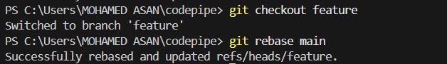

Stash :

